Amanda Copley

ACopley@K12.WV.US

Advanced Career

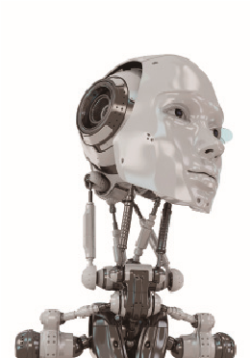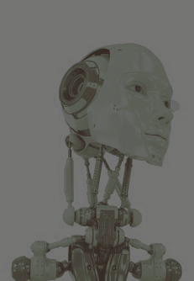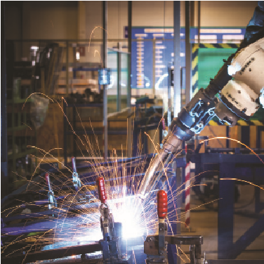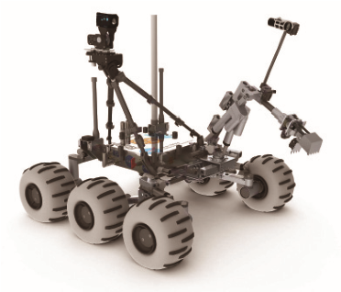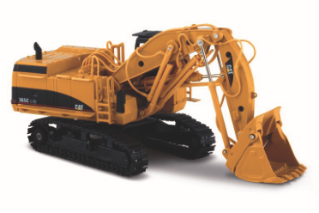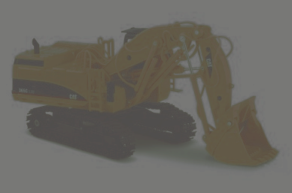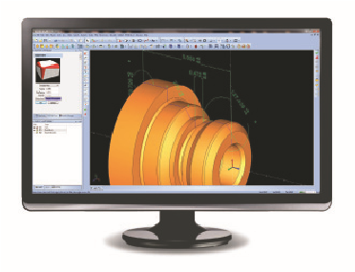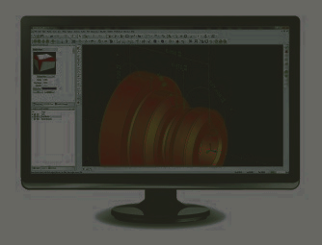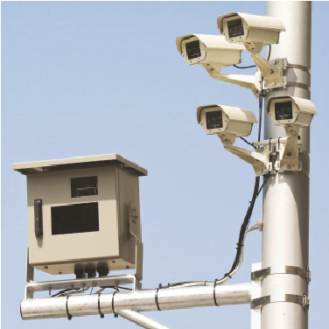

**Integrated Production Technologies**

**Course 1:**

**Advanced Technology for Design and Production**

Manufacturing & Automation I

Syllabus

**Advanced Career (AC)**

*A multi-state consortium to develop curricula, assessments, instructional materials, and teacher/ counselor/leader training to provide more students with relevant and challenging career-technical courses*

# Course

# Syllabus Integrated Production Technologies: Advanced Technology for Design & Production

**Course Description**

This course engages students in the use of modern technologies in the design and improvement of products. Students use three-dimensional CAD software in the creation and analysis process. Students document designs using standards set by industry for design documentation. Students implement methods of green production and just-in-time component supply, which allow for the lowest cost and highest quality products. Students design and troubleshoot data acquisition, programmable logic control, process monitoring, automation, and robotic systems. Students incorporate sensing and vision systems, utilizing cameras and sensors to control automated systems.

**Instructional Philosophy**

The Advanced Technology for Design and Production course requires AC students to engage in authentic projects they might encounter in the workplace. Students complete a variety of challenging projects designed to prepare them for employment and a variety of options for training and college after high school. To complete challenging work-related projects, students participate in a variety of learning activities that require the use of technology, software, and academic skills such as reading, writing, mathematics, and science that are essential to success in design and production and many other high-demand careers.

Students read technical texts in the design and production fi eld to acquire background information; they frequently consult supporting documents to complete the project assignment. Students maintain and use an Engineering Notebook to keep track of notes, design and production vocabulary, citations, reflections, and project notes gained from background reading and class work. At the end of each project, students develop a written explanatory/informative or argumentative document in a format used by manufacturing professionals to communicate their work to others.

In this information-centered economy, the ability to read the technical documents of the fi eld is an essential skill. Success in the modern economy demands that students be able to read these dense technical materials, write about what they had learned, and present their findings orally to various stakeholders. AC views literacy as a fundamental skill for the 21st century that allows students to apply the varied technical skills that drive the AC curriculum.

Students apply knowledge of scientific information and processes as appropriate to complete each project. They also apply algebra and statistical concepts (e.g., data collection, data analysis, and descriptive statistics) learned in high school mathematics courses. At the conclusion of each project, individual students and their teams make an oral presentation to an audience of one or more professionals in engineering, design and production, or other related fi elds.

**AC students take responsibility for their own learning, demonstrating autonomy and innovation in solving problems posed by the AC Integrated Production Technologies projects.**

Individual students and student teams take ownership of the project, but teachers provide instruction as needed on learning skills that increase self-reliance and teamwork. As the student and the team progress through the projects, the teacher gives students additional voice and choice on how to complete the project. Serving as facilitators, teachers ask insightful questions that cause students to reflect on their work. They also teach mini lessons on necessary technical skills that students have been unable to learn independently (e.g., reading strategies for managing difficult reading assignments, writing skills, and mathematics and/ or science concepts). Under the guidance of a skilled teacher-facilitator who knows how to ask the right questions to lead students to find answers on their own, teams increase their independent research and project work. The teacher-facilitator provides criteria to ensure quality work and supports students who need extra help to achieve the high-quality performance expected in AC courses.

**To ensure success as a postsecondary student, employee, business owner, or entrepreneur, AC Integrated Production Technologies students must meet high expectations regarding quality of work and personal behavior.** Students arrive at class on time with all necessary materials. They redo major assignments until they meet the high-quality AC standards. They sometimes require before- or after-school tutoring and extra-help sessions. Since AC courses include rigorous work, students can expect to complete homework and out-of-class project assignments.

**AC students work in teams and complete individual assignments related to the team's work.** Like teams in the workplace, AC Integrated Production Technologies team members are collectively and individually responsible for the success of a project and for ensuring that each team member masters related academic and technical content and demonstrates the 21st-century skills of teamwork, critical thinking, and problem solving. Students evaluate their work and that of others, using scoring guides provided by the AC teacher.

**AC Integrated Production Technologies students frequently use technology.** In Course 1, students use a variety of computer software for design, testing, and creating products using advanced technologies. They learn about input and output control and visualization software (e.g., Solid Edge). Students use Cloud or Internet-based applications such as social media, texting, and electronic survey instruments. They use electronic media to interview professionals in the design and production fi eld, participate in virtual fi eld trips, and use digital cameras and/or recorders and related software.

**AC students interact with design and production experts.** As appropriate, students participate in fi eld trips and/or interact with professionals. Community experts serve as guest speakers, project mentors, and authentic audience members to provide feedback at the conclusion of each project.

Teachers coach students in the behavior and expectations of design and production professionals. Students exhibit professional standards of dress and behavior.

**This course requires AC students to adhere to safety and quality standards expected on the job.** Students complete class activities, projects, and problems by using the planning and thinking methods of design and production professionals. Throughout the project, the teacher checks for understanding through Engineering Notebook entries, questioning, and work reviews. Students use self-evaluation and peer-evaluation scoring guides throughout a project. As in the workplace, students revise work until it meets quality standards, and they follow all safety requirements.

**Students complete an end-of-project exam, final products/deliverables, a professionally written report on their work, and an oral presentation at the end of each project**. Mirroring final products, presentations, or certification exams in the workplace, students do not revise or redo these final assessments. These serve as a means for assessing the academic, technical, and technology knowledge and skills students acquire through each project. At the completion of Course 1, teachers administer an end-of-course exam to each student. A team consisting of high school and college

academic and technical teachers and design and production professionals developed the exam to ascertain mastery of essential academic, technical, and 21st-century knowledge and skills. The exam is similar to employer certification exams. Students read, interpret, paraphrase, summarize, and analyze technical materials; answer technical, mathematics, and science questions; and complete mathematics problems.

**Course Goals**

Students in Advanced Career (AC) Integrated Production Technologies Course 1: Advanced Technology for Design and Production do the following:

* Use terminology of the field.
* Research design and production technical texts, journal articles, and related documents.
* Use the Engineering Design Process.
* Use design and production concepts to solve problems.
* Relate manufacturing to societal principles, including economic implications.
* Use design and production tools to make decisions and solve problems.
* Apply project management principles.
* Gain information on how the American manufacturing industry works.
* Use appropriate and effective research skills.
* Use best practices to design and implement research studies.
* Use science practices to design investigations.
* Demonstrate proficiency in word processing, spreadsheets/databases, and presentation software.
* Communicate information, including descriptive mathematics, to audiences.

**Major Projects/Problems and Assignments**

## Project 1: Reverse Engineering/Manufacturing Basics

**Essential Question (EQ):** How do we reverse engineer and document a product to capture design decisions and physical characteristics?

This project engages students in reverse engineering a toy. Students investigate the manufacturing process for the toy and produce models and a plan for rapid prototyping of the toy. Through research on design and production processes, and creating models for rapid prototyping, students gain an understanding of basic manufacturing processes.

**Project 2: Manufacturing’s Role**

**Essential Question (EQ):** How can we design a manufacturing process to mass produce a new product?

Students use the Engineering Design process to investigate processes used to mass produce a new product. Students create drawings of the product. Students determine a bill of materials for the product and complete a plan for mass producing the product.

**Project 3: Direct Current (DC) Motors**

**Essential Question (EQ):** How can we design a working DC motor hobby kit with accompanying instruction manual?

This course consists of the design and creation of a direct current motor kit and instruction manual.

Students research electric motor design and the uses of electric motors in the manufacturing industry. Students use the Engineering Design process to design, build, and test an electric motor and communicate the results of their design process.

## Project 4: Thermoforming and Temperature Control

**Essential Question (EQ):** How can we design a system to monitor the manufacturing process and quality of a product?

Students investigate the processes associated with creating thermoformed parts. The control and monitoring of temperature is explored through active exploration with thermoforming equipment and data acquisition. Students use technology to monitor and control the thermoforming process.

## Project 5: Tank Volume Control - Automated Decision Making

**Essential Question (EQ):** How can we design an automated system to maintain proper volumes of

liquids in tanks prior to shipping and storage?

Students develop an automated system to maintain a constant volume of liquid in an industrial tank. This includes measuring the tank volume and adding or removing liquid as needed to maintain a constant volume. Students use fluid sensors and programmer logic controllers. They develop critical thinking, data analysis skills, and an understanding of the laws of thermodynamics by observing how different fluids and tank materials respond to heat transfer.

## Project 6: Batch and Separation System

**Essential Question (EQ):** How can machines use optical sensors for automated sorting?

Students are challenged to design an automated system that analyzes data about a product, then sorts that product based on criteria. Students research automated systems of detection and create a prototype system that will sort products. The design of the system will include investigations into optical imaging systems and control processes.

**Engineering Notebook**

Each student maintains an Engineering Notebook for each project, either an electronic notebook or a paper version. Students take notes, defi ne terms, develop project plans, and write reflections in their notebooks. Teachers check the notebooks periodically to measure understanding; to help students manage the work; and to determine the need for additional teaching, clarification, or practice.

**Career Investigations**

Each project contains a career component that allows students to explore design and production, manufacturing, engineering, or related careers and the skills associated with success, including educational requirements.

**Instructional Delivery Plan**

AC curricula, including the Integrated Production Technologies curriculum, use the project-based learning (PBL) method. Teachers introduce each project with an entry event to give students an overview of the problem and to develop interest. Subsequently, students work in teacher-assigned teams to determine what they need to know and do to solve the problem. They develop a team calendar and a work plan to record team expectations and methods of collaboration. As students become proficient in PBL, the teams have greater autonomy or independence. If teachers see a need for additional technical or academic knowledge and skills for students to complete the project, they provide instruction in the form of mini-workshops for teams that are ready for the information or whole-class instruction on the topic.

Teachers using PBL serve as facilitators rather than disseminators of information to students.

**Frequently, teachers answer students’ questions with more questions, challenging them to think for themselves or to conduct research rather than rely on the teacher for answers.** AC Integrated Production Technologies students may need to use tutorials or other resources to learn software rather than rely on the teacher for instruction. Mini-workshops, some whole-class instruction, and independent learning are reflections of the world of work, where professionals use all three methods to learn new skills. Employees in high-skill jobs seldom do their work by using skills based on categories such as reading, writing, mathematics, or science. Instead, workers, business owners, and entrepreneurs integrate various skill sets to solve complex problems. That is why AC projects require students to use academic skills such as reading, writing, mathematics, and science to solve technical or career-related problems. Occasionally, students work with other teachers to obtain answers to academic questions or with industry experts to find project-related information.

AC teachers use “just-in-time” instruction, for example, to teach mathematics concepts needed by students to complete project assignments. This method assembles students into small groups or pairs (i.e., different from their project teams) to learn mathematics skills. After the instruction, project teams use the new skills to create a product or solve a problem.

All AC projects require each student to prepare a final written product, using formats similar to those in the career area. If students complete research, participate in learning activities, and keep good notes in an Engineering Notebook, they find it easier to produce the final product. All AC projects include an oral presentation to an authentic audience of professionals in the fi eld. Audience members use rubrics or scoring guides to evaluate the technical and oral aspects of the presentation and to provide feedback to the teams.

To complete a project, students work both independently and with a team. **Individual members ensure that all team members demonstrate understanding of the concepts and procedures used in solving the problem.** The teacher assigns a group grade for the project based on the team’s work and an individual grade based on the Engineering Notebook, a student’s individual paper, independent work, a student’s individual portion of the oral presentation, and end-of-project and course exam.

Weekly extra-help sessions after regular class hours provide support for individual students and teams.

AC Integrated Production Technologies teachers frequently review the work of individuals and teams. They review Engineering Notebooks weekly to monitor progress and provide suggestions to help individuals and teams redirect their energies, as needed. A teacher may recommend or require an extra-help session. Because AC is an advanced program, students expect frequent homework and out-of-class assignments to complete projects. AC teachers may use the “flipped classroom” approach that allows students to view online videos of teacher-led demonstrations or homework explanations outside of class so that more class time is available for students’ collaborative work.

Extra-help sessions may include the following:

* Reteaching to small groups of students during class time
* Tutoring or extra help outside of regular class time
* Redoing assignments as homework
* Tutoring by subject-area teachers in reading, writing, mathematics, and science

**Assessment Plan**

AC courses include two types of assessment—formative and summative. Teachers use formative assessments to determine the need for additional instruction. Typically, teachers do not score formative assessments until students demonstrate mastery of knowledge and skills. Students use formative assessments (e.g., checklists, rubrics, and peer or teacher feedback) to determine what or how to improve. Students usually redo formative assessments until the work reaches the high standards expected of AC students. Students sometimes redo work after class hours, during extra-help sessions or homework, to avoid slowing the pace of the team or the class.

Summative assessments measure how well students have mastered academic, technical, technology, and 21st-century standards at the end of an assignment, a project, or a major assessment, such as an end-of-project or end-of-course exam. Students ordinarily do not redo summative assessments (e.g., oral presentations to authentic audiences, final products, and end-of-project or end-of-course exams). The assessment plan for the AC Integrated Production Technologies course includes five components:

1. **Engineering Notebook:** Students maintain an electronic portfolio or a written notebook for each project. The purposes are to document the investigative process and research; to develop organization skills necessary for success in continuing education, the workplace, and in completing the written product at the end of the project; to write daily reflections on new insights; to practice the inquiry process for group and individual questions; and to use the notebook as a study guide. AC teachers use the notebooks as formative assessment to check for student understanding and to reteach as needed. The AC teacher supplies a rubric and a due date for the notebooks.

An Engineering Notebook contains the following types of work used by a student to complete a project:

* + Daily and weekly reflections.
  + Essential technical vocabulary.
  + Notes from technical readings, interviews, and fi eld experiences.
  + Practice mathematics problems.
  + Science lab reports.
  + Career investigations.
  + Other assignments completed during the project.

1. **21st-Century Skills:** The 21st-century skills are the personal skills necessary to compete in a global economy that demands innovation by workers, business owners, and entrepreneurs. Competition in the modern economy requires an understanding of global awareness; financial, economic, business, and entrepreneurial literacy; and civic, health, and environmental literacy.

AC courses include a variety of tools and strategies to enable students to use these skills. Teachers assess students’ understanding and application of 21st-century skills by rating how they

1) take responsibility

2) help the team

3) respect others

4) make and follow agreements

5) organize work

6) build teamwork

They also assess how students participate in classroom and lab activities and adhere to lab safety rules. When assignments require students to interact with community experts, academic teachers, or other adult mentors, the teacher observes and scores the student’s ability to communicate in a professional manner. The AC Integrated Production Technologies teacher grades 21st-century skills through observation, peer- and self- evaluation, and Engineering Notebook entries.

1. **Project Academic and Technical Tasks:** Evaluation includes the demonstration of academic tasks, such as solving mathematics problems, applying science concepts, reading technical and academic materials, writing information/explanatory or argumentative texts, and making oral presentations to a specific audience. In most projects, approximately 50 percent of the tasks involve application of academic knowledge and skills; approximately 50 percent demonstrate mastery of technical skills and use of technology and software. Tasks in most Integrated Production Technologies projects include a blend of academic, technical, technology and 21st-century skills. AC teachers evaluate students' demonstrations of understanding, reasons, processes, and procedures. AC students demonstrate quality, creativity, and efficiency of work resulting in solid design and performance of project deliverables.
2. **End-of-Project Exams**: Each project includes an end-of-project exam designed to assess whether or not each student mastered the academic and technical content required to complete the project. In other words, can each student actually read and comprehend the technical materials? Can each student actually do the mathematics to complete the project? Can each student demonstrate understanding of the science concepts underpinning the project? Can each student demonstrate mastery of technical content knowledge and the knowledge and skills to use the technology and software needed to complete the project? The end-of-project exam is designed to ensure that one student on the team did not do all of the reading, mathematics, and academic applications while others watched. The assessment includes multiple-choice questions, mathematics problems, science questions, and constructed-response questions that require students to write clearly for a specific audience and demonstrate the ability to respond to a specific work-related problem. AC students read technical materials and demonstrate understanding of the technical text. The exams include questions related to 21st-century skills, such as developing a work plan, researching possible solutions, and working together with peers and experts. Because the end-of-project exams may build on the knowledge and skills of prior projects, they may contain questions from previous projects. Fifty percent of the end-of-project exam questions relate to technical and technology content; 50 percent relate to academic and 21st-century skills. Some questions overlap into both categories.
3. **End-of-Course Exam:** AC courses include a rigorous, comprehensive national end-of-course exam to assess technical, academic, and 21st-century skills. The exam is a final assessment of whether or not students have retained the understanding and skills acquired through several projects they have completed. It is recommended that the final exam represent 30 percent of a student's grade; however, this is a decision each school must make. AC students should take this exam seriously because it is expected that it will be used by some states as the basis for awarding an industry certification, academic credit, or dual credit for high school and college.

The end-of-course exam mirrors employer certification exams; college-readiness exams for mathematics, science, and language arts; and authentic workplace scenarios and technical questions. Approximately 50 percent of the end-of-course exam consists of items related to literacy, mathematics, and science; approximately 50 percent relates to technical knowledge applied through the course. Some exam items may address the habits of mind and behavior that are fundamental to 21st-century skills.

**Grading Protocol**

**Project Grade:** Teachers determine individual grades by assessing students’ mastery of knowledge and skills based on a list of project deliverables, rubrics, scoring guides, and project exams. Three assessment components make up the project grade. The teacher calculates the grade by dividing the number of points earned by the number of points possible. The following table contains three project assessment components with the corresponding weight relative to the project grade.

## Project Grade Distribution

**Nine-Weeks Grade:** The teacher determines the grade for each nine-week grading period by calculating grades from projects completed during the period.

|  |  |
| --- | --- |
| Technical and academic grades from completed projects and written products | 10% |
| Tests/Mid-Terms/Final Exam | 50% |
| Engineering Notebook:  21st-century skills assessments from all completed projects | 25% |
| Daily hands-on activities; attendance | 15% |

**Final Course Grade:** District policy determines the final grades for completion of the AC Integrated Production Technologies course. Averaging the grades from each grading period might account for 70 percent of a student’s final grade, and the end-of-course exam could account for 30 percent.

**Class Expectations/Rules/ Procedures**

1. **Respect yourself, the teacher & others**

* Show respect for the teacher, yourself, and others at all times.
* Respect others’ property. Avoid touching or writing on anything that does not belong to you (including desks, textbooks, teacher’s belongings, walls, chalkboard, etc.).
* Don't expect that others will clean-up your messes. Please pick-up after yourself.
* Respect yourself and the rest of us by using appropriate language and wearing appropriate clothing.
* Be a kind person.
* Offensive, derogatory, and profane terms are not tolerated.
* In order to have a safe classroom environment where all students feel comfortable, no put downs, swear words, or slang words with demeaning connotations will be accepted.
* Remember, if you don’t have something nice to say, don’t say it at all!

2. **Put forth your best effort at all times**

* Always do your own best work.
* Put learning ahead of getting good grades.
* Put quality ahead of just getting it done.

3. **Be prepared for class each day**

* Come prepared with all materials necessary:
* Composition Notebook/Engineering Notebook
* (Blue or Black) Pen
* Highlighter

4. **Follow directions**

* When directions are given, do your best to follow them the first time. If you are confused or have questions, ask. I would rather have you stop class to clarify than be off task while everyone else is working.

5. **Pay attention, participate, and ask questions**

* Engage in what is going on in the classroom.
* If you have a question, ask it! Otherwise, I might not know until the test that you did not understand something. There are no stupid questions, and chances are, if you are wondering about it, someone else in the class is to. Be proactive about your learning and don’t be afraid to ask for help. If you feel most comfortable waiting until after class, that is okay, too, but do keep communication open between us.

6. **Preserve a positive learning environment**

* Student actions that interfere with teaching or learning in the classroom will NOT be tolerated.
* Use class time to learn. Please do not spend your time grooming, sleeping, talking, writing notes, playing cards, listening to music, texting, or doing work for other classes.
* Minimize classroom interruptions by arriving to class on time and not leaving the classroom.

7. **Take responsibility for your actions**

* If you are confronted about a rule infraction, own up to it.
* Don’t deny it, lie about it, or blame someone else.
* Take responsibility for missed assignments.
* Do not cheat, plagiarize, or copy work

1. Turn off cell phones

2. No food or drink.

4. Never line up at the door before dismissal

7. **Do your best work & turn it in on time**

* Remember that the work that you turn-in is a reflection of your effort on the assignment. Think about the following expectations when you are preparing an assignment that I will review:
  + Write your full name
  + All work must be neatly done and legible in order to receive full credit.
  + Homework is due at the beginning of the hour when you come to class. I will not accept work completed once class begins. After 3 day late it will remain a zero.

3. **Tardies:**

* After 3 they will be turned into the office.
* Excessive tardies will affect your learning.

5. **missed work**

* Talk to your peer, and/or ask the teacher
* Attendance is essential for optimal learning. Being on time and present and class physically and mentally will be part of your overall grade.
* You may not be excused from my class by another teacher without first seeking my permission.
* If you are absent, it is your responsibility to obtain any missed classwork. Then ask another student what you missed. Follow-up with the teacher if necessary.
* Make arrangements to take quizzes and tests immediately. It is your responsibility to make these arrangements. I will not and cannot track you down. If you do not make-up quizzes in a timely manner, you will earn a “zero” on the quiz or test.